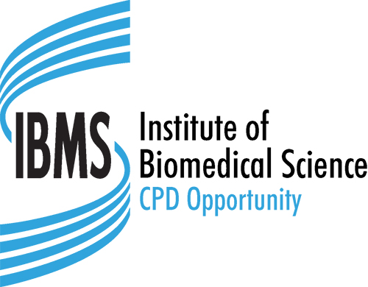
Institute of Biomedical Science
Education Department, 12 Coldbath Square, London, EC1R 5HL
Tel: 020 7713 0214 – Fax: 020 7837 9658
E-mail: cpd@ibms.org

CPD Events and Courses

Advertisement Application

IBMS CPD Event or Course Confirmed (For official use only)
Staff name: | Signed: | Date:

Please complete ALL sections of the application in BLOCK CAPITALS/TYPESCRIPT. Failure to submit sufficient detail may cause a delay in upload and advertisement. Please return the completed application and full activity programme (e.g. Agenda) to cpd@ibms.org

By completing this form you are confirming that you want to advertise your event on the IBMS Website.
Activity Submitted by: |  |  |  |  |  | IBMS Membership No:
Activity Title
Activity Summary |  |  |  |  |  |  | Activity Details
 |  |  |  |  |  |  | Date(s) of Activity:
 |  |  |  |  |  |  | Venue:
CPD Category (Please tick one option only)
Formal Education |  |  | Professional Activity |  |  |  |  |  | Self-directed Learning
Work Based Learning |  |  | Other
Tag words (likely search words to help members to find the activity on the website)
Content (web content, links to external websites etc.)
Contact Address (for correspondence) |  |  |  | Contact Details (for advertising)
Name: |  |  |  | Name:
Address: |  |  |  | Tel:
 |  |  |  |  E-mail:
Post Code: |  |  |  |  Website:

Key Learning Outcomes and Reflection Topics (required)
Please continue on a separate sheet if necessary
In providing IBMS with the information requested you are consenting to its use as indicated in the IBMS Privacy Notice. Further information can be found on the IBMS website at https://www.ibms.org/privacy/

