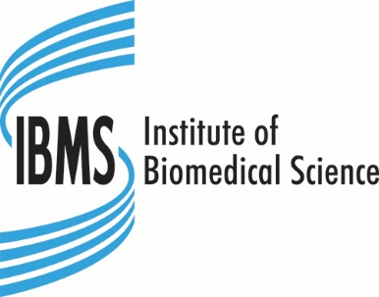

CERTIFICATE OF EXPERT PRACTICE IN MOLECULAR PATHOLOGY 2023
APPLICATION FORM

IBMS Membership Number: _________________

Title: Surname: Forename:

Date of Birth: (DD/MM/YY)

Job Title:

Please briefly outline your reason(s) for undertaking qualification:

Address for all correspondence including examination results:

Email:

Telephone No: ______________________ Mobile No: ______________________

Employment address if different from above:

Email:

Telephone No: ______________________ Mobile No: ______________________
Declaration
If an applicant subsequently gains the Institute’s Certificate of Expert Practice in Molecular Pathology on the basis of incorrect information, this may give them a pecuniary advantage by deception. In such circumstances the Institute may withdraw the Certificate. The onus for ensuring the full and accurate disclosure of information rests with the applicant.
- I declare that the information given in this document and in all attached forms is true and accurate.
- I understand that failure to disclose full information or any deliberate misrepresentation of information can be a serious matter and will invalidate my application.
- In providing IBMS with the information requested you are consenting to its use as indicated in the IBMS Privacy Notice. Further information can be found on the IBMS website here.

Signature of Applicant: Date:

Signature of Manager: Date:

Payment Details

Purchase Order
Please invoice my employer
Purchase Order (PO) Number: ____________________________________________
Please note the actual Purchase Order must be provided rather than just the number and the PO should accompany the completed application form

Card Payment
I wish to pay by credit/ debit card
For security reasons rather than providing your card details on this form we will contact you via telephone on receipt of this form to get that information.

Completed forms together with the examination fee of £710 should be submitted to
examinations@ibms.org

Please note: Places for the course are limited to a maximum of 60 and will be allocated strictly on the order in which completed applications forms arrive at the IBMS.

A signature of a manager is not required if the applicant is paying the examination fee

