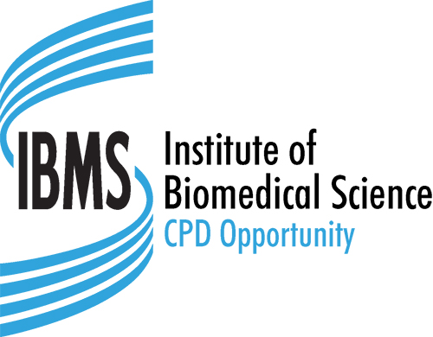
Institute of Biomedical Science
Education Department, 12 Coldbath Square, London, EC1R 5HL
Tel: 020 7713 0214 – Fax: 020 7837 9658
E-mail: cpd@ibms.org

CPD Events and Courses Attendance Sheet

Activity Title
Activity Summary |  |  |  |  | Activity Details
 |  |  |  |  | Date(s) of Activity:
 |  |  |  |  | Venue:
CPD Category (Please tick one option only)
Formal Education |  | Professional Activity |  |  |  |  | Self-directed Learning
Work Based Learning |  | Other
Content (web content, links to external websites etc.)
Contact Address (for correspondence) |  |  | Contact Details (for queries)
Name: |  |  | Name:
Address: |  |  | Tel:
 |  |  |  E-mail:
Post Code: |  |  |  Website:

Key Learning Outcomes
Please continue on a separate sheet if necessary

Key Reflection Topics
Please continue on a separate sheet if necessary

